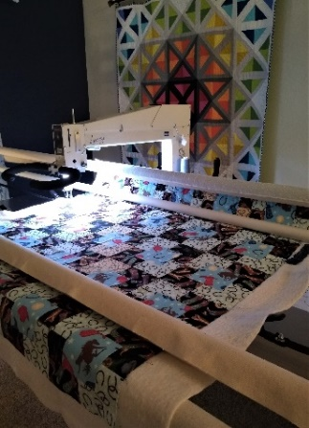
Comfort and Joy Quilter
www.comfortandjoyquilter.com
comfortandjoyquilter @ gmail.com
425-773-3627

Date______________________________________________

Order Form

Please fill out the information in the dotted box below. We’ll talk about the rest when you drop off your quilt.

Customer _________________________________________________ Home Phone __________________________

Email ______________________________________________________ Cell Phone ___________________________

Referred by? _______________________________________________ Okay to text photos? Y N

What will you be using this quilt for? _____________________________________________________________
______________________________________________________________________________________________________

May I post photos of your quilt on my website and social media? Y N Other_________________

Quilting motif/Design ______________________________________________________________________________
______________________________________________________________________________________________________
______________________________________________________________________________________________________
______________________________________________________________________________________________________
______________________________________________________________________________________________________
Batting __________________________________________ Customer provided? Y N
Thread ______________________________________________________________________________________________
Other services ______________________________________________________________________________________
Need by date ____________________________________ Price Quoted $__________________________________
Notes _______________________________________________________________________________________________
______________________________________________________________________________________________________

